MIDTERM EXAMINATION
Fall 2008
MTH101- Calculus And Analytical Geometry
Time: 60 min
Marks: 38
Question No: 1 ( Marks: 1 ) - Please choose one
The average velocity of a body is 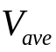

► 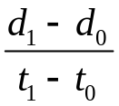
► 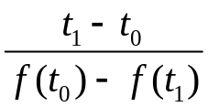
► 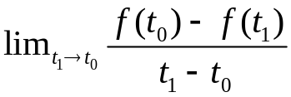
► None of these

Question No: 2 ( Marks: 1 ) - Please choose one
Consider two function 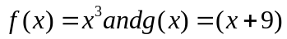 then 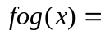

► 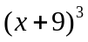
► 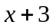
► 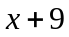
► None of these

Question No: 3 ( Marks: 1 ) - Please choose one
Consider two function 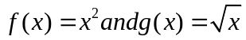 then ..................

► -correct
► 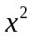
► 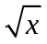
► None of these

Question No: 4 ( Marks: 1 ) - Please choose one
Consider two function 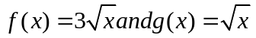 what is true about these functions

► 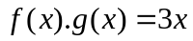
► 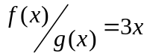
► 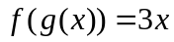
► None of these -correct

Question No: 5 ( Marks: 1 ) - Please choose one
The centre and the radius of the circle 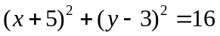 is

► (-5,3) ,4
► (5,-3),16
► (5,-3),4
► None of these

Question No: 6 ( Marks: 1 ) - Please choose one
The graph  is symmetric about

► X-axis
► Y-axis
► Origin
► None of these

Question No: 7 ( Marks: 1 ) - Please choose one
The chain rule is used for two function f and g , if we have ---------- of these function

► Product
► Sum
► Composition
► None of these

Question No: 8 ( Marks: 1 ) - Please choose one
A function f is differentiable function if it is differentiable on the interval

► 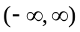
►
► 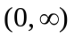
► None of these

Question No: 9 ( Marks: 1 ) - Please choose one
A function is said to be continuous function if the function is continuous on the interval

► 
► 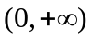
► 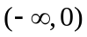
► None of these

Question No: 10 ( Marks: 1 ) - Please choose one
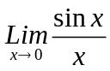

► 1
► 2
► 0-correct
► 1/2

Question No: 11 ( Marks: 1 ) - Please choose one
For any polynomial 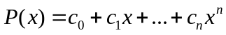 and any real number a 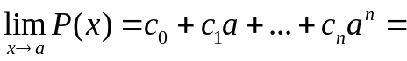

► 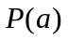-correct
► 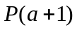
► 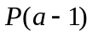
► 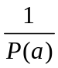

Question No: 12 ( Marks: 1 ) - Please choose one
The no of x and y intercepts for the equation y=1/x
► Two x intercepts
► Two y intercepts
► No x and no y intercepts-correct
► None of these

Question No: 13 ( Marks: 1 ) - Please choose one
A line is called a tangent line to the circle if it meets the circle at precisely ……………..

► One point -correct
► Two points
► Infinite points
► None of these

Question No: 14 ( Marks: 1 ) - Please choose one
If f is a twice differentiable function at a stationary point  and 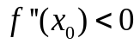 then f has relative …………. At

► Minima -correct
► Maxima
► None of these

Question No: 15 ( Marks: 1 ) - Please choose one
If the 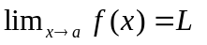then the inequality 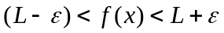 holds in any subset of the interval

► 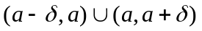
► 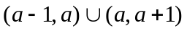
► 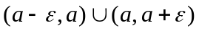
► None of these

Question No: 16 ( Marks: 1 ) - Please choose one
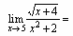

► 0
►
► 1/9
► Limit doesn't exist

Question No: 17 ( Marks: 2 )
Show that 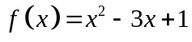 is a continuous function.
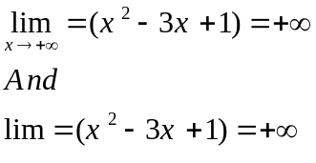

Question No: 18 ( Marks: 2 )
Find the range of function  defined by 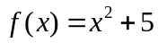

Question No: 19 ( Marks: 3 )
Differentiate: 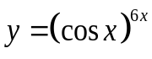

Question No: 20 ( Marks: 5 )
Differentiate w.r.t. x by chain rule 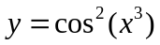

Question No: 21 ( Marks: 10 )
Evaluate the following limit.


